1. **CRUD Operations on Book Entity**

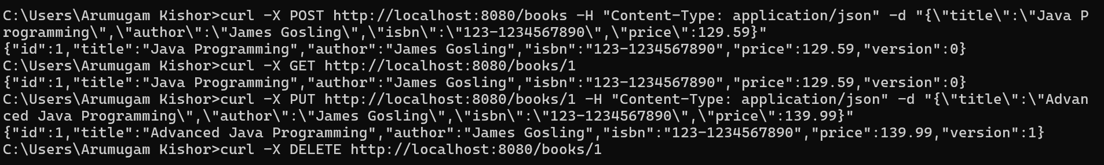

1. **CRUD Operations on Author Entity**

